REGRESSION ANALYSIS AND TIME SERIES FORECASTING OF WORLD HAPPINESS REPORT

Background and Introduction
Often, we come across a question- "What is the formula for happiness?" There is no established scientific formula for happiness known to the world at present. However, there are several determinants that determine the happiness of a nation taken as a whole. The World Happiness Report released by UN is a landmark survey of the state of global happiness. The purpose of the happiness report is to survey the science of measuring and understanding subjective well-being.

Problem Statement

Increasingly, happiness is the proper measure of social progress and the goal of public policy. The report continues to gain global recognition as governments, organizations and civil society progressively use happiness indicators to back their policy-making decisions. Leading experts across fields describe how measurements of well-being can be used effectively to assess the progress of nations. The report reviews the state of happiness in the world today and show how the new science of happiness explains personal and national variations in happiness.
The aforesaid study shows that India is losing its happiness consistently despite being on the progressive tract. Hence, in this project, we are leveraging the UN's World Happiness Report to try to understand the relationship of the determinants contributing to the happiness score of the country. With this, we intend to build a regression model that predicts the happiness score of a country for the year 2017 with a given set of predictor values. Also, we aim to build a time series forecasting model that predicts the happiness score of India for the next 5 years. This study will further help the government bodies propose or formulate public policies with an aim to restore the happiness of the country at large.

Data Summary

The data for this project is taken from the UN World Happiness Report 2018. The survey measure of Happiness Score is from the Dec 22,2017 release of the Gallup World Poll, which covers the years from 2005 to 2017.
The variables are as summarized below-

Var. | Variable Name | Description | Variable Type | Code Description
1 | Life Ladder | It is the response variable also known as Happiness Score or Cantril Ladder | Numerical | Between 0 to 10
2 | Country | 156 countries of the world | Character
3 | Year | Data from year 2005 to 2017 taken from the GWP survey | Numerical
4 | Log GDP per capita | It is the purchasing power parity of a country at constant dollar prices | Numerical
5 | Healthy Life Expectancy at Birth | It is calculated based on the statistics published in journals. | Numerical
6 | Social Support | Response to the question-  "If you were in trouble, do you have relatives or friends you can count on to help you whenever you need them, or not?" | Binary | 0- No  1- Yes
7 | Freedom to make life choices | Response to the question-  "Are you satisfied or dissatisfied with your freedom to choose what you do with your life?” | Binary | 0- No  1- Yes
8 | Generosity | It is the residual of regressing national average of response to the GWP question “Have you donated money to a charity in the past month?” on GDP per capita. | Numerical
9 | Corruption Perception | The measure is the national average of the survey responses to two questions in the GWP: “Is corruption widespread throughout the government or not” and “Is corruption widespread within businesses or not?” | Binary | 0- No  1- Yes
10 | Positive affect | It is defined as the average of three positive affect measures in GWP: happiness, laugh and enjoyment | Numerical
11 | Negative affect | It is defined as the average of three negative affect measures in GWP: worry, sadness and anger | Numerical
12 | Confidence in national government | The English wording of the question is “Do you have confidence in the national government?” | Binary | 0- No  1- Yes
13 | Democratic quality | Democratic and delivery quality measures of governance are based on Voice and Accountability, Political Stability and Absence of Violence, Government Effectiveness, Regulatory Quality, Rule of Law, Control of Corruption. | Binary | 0- No  1- Yes
14 | Delivery quality |  | Binary | 0- No  1- Yes

Data Exploration and Visualization

Data visualization techniques are applied on the dataset to explore the dataset further. The techniques used are-

- Histogram- Histogram of the output variable, Happiness Score shows the distribution of the data. For our dataset, we plotted Happiness Score for years 2014 to 2017 and observed that the number of countries in the higher Happiness Score range (6+) is gradually decreasing. Also, it indicates that the Happiness Score for the maximum countries of the world is between 4 to 6.

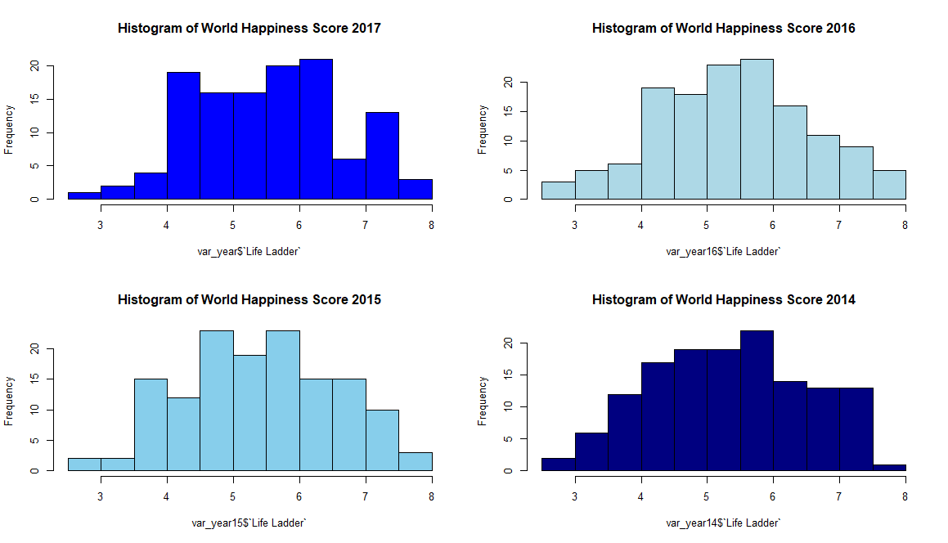

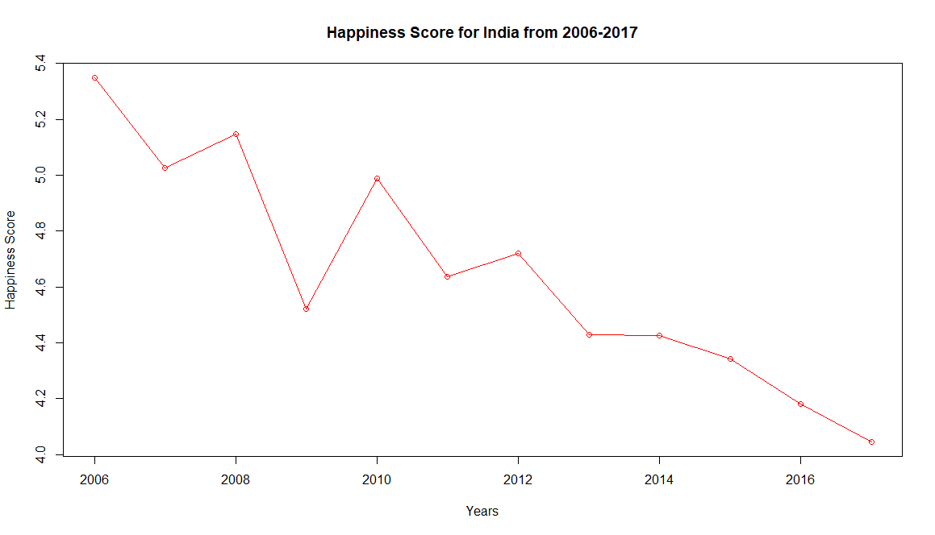
The line plot for India’s Happiness Score from 2006-2017 shows a significant decline.

- Heatmaps- Heatmaps helped us to visualize the correlations between variables and the missing values.
The original dataset had 1562 observations with 14 variables (13 input and 1 output). The summary of this dataset gave us the missing values of each variable. The correlations between variables indicated that Life Ladder is very weakly correlated with Generosity, Negative affect and Confidence in National government, and hence can be dropped from our further analysis.
But, we retained all the 13 input variables for our initial analysis.
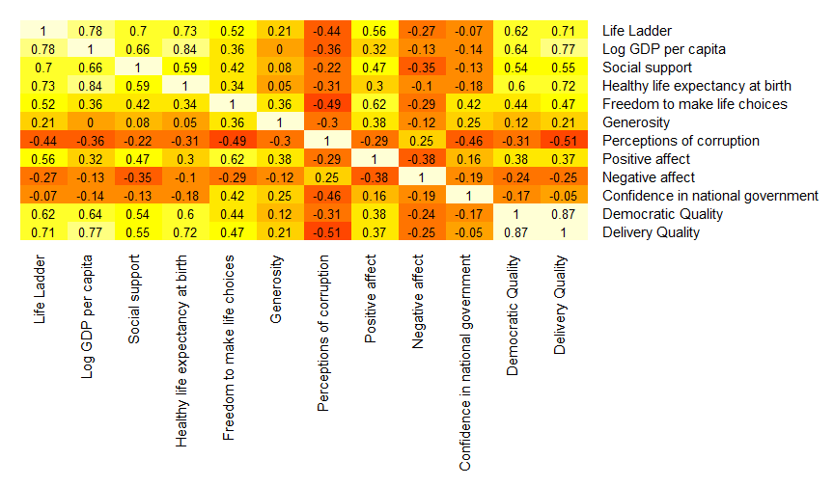

- Boxplots- Side-by-side boxplots of input variables helped us identify the outliers. There were not many outliers in the original dataset. The final dataset shows no outliers in the input variables.

III. Data Preparation and Preprocessing

Imputation of missing values

On studying the dataset further, we found that few records had missing values for more than 3 variables. Such observations with 3 or more missing values are deleted from the dataset since 3 or more missing values contribute to more than 25% missing information in a record. And filling the missing values of such records with random values or aggregated values might not result in a good model. Hence, we decided to drop such observations from our dataset.
Average imputation was performed on the records with 1 or 2 missing values of the predictors.
Thus, the final dataset resulted in 1501 records with 14 variables.

Data Standardization

The input variables have different scales and units. Scaling of data is essential because otherwise a variable may have large impact on the prediction variable only because of its scale. Thus, to bring all these input variables on the same scale, we used standardization on our dataset (except Country and Year). It transformed the dataset to have zero mean and unit variance. This standardized dataset is used for further analysis.

IV. Data Mining Techniques and Implementation

Model 1: Regression with Random forest

Training Dataset: The training dataset for the case study is a selection of 1380 observations of 12 variables where Year < 2017 i.e. observations for all the countries from 2005-2016.
Validation Dataset: The validation dataset for the case study is a selection of 121 observations of 12 variables where Year = 2017 i.e. observations for 121 countries for the year 2017.

The model was first trained with the training dataset and then it was used to predict the values of the validation dataset. In other words, the model was first trained with the life ladder values of all the countries from year 2005 to 2016 and the same model later was then used to predict the life ladder values for the year 2017. The RMSE and R squared values for the training model are-

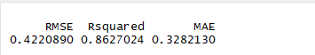

This indicates that the model has a high predictive value (accuracy). The training model also helped us identify the six most important input variables- Log GDP per capita, Healthy life expectancy at birth, Social support, Delivery Quality, Positive affect and Democratic Quality.
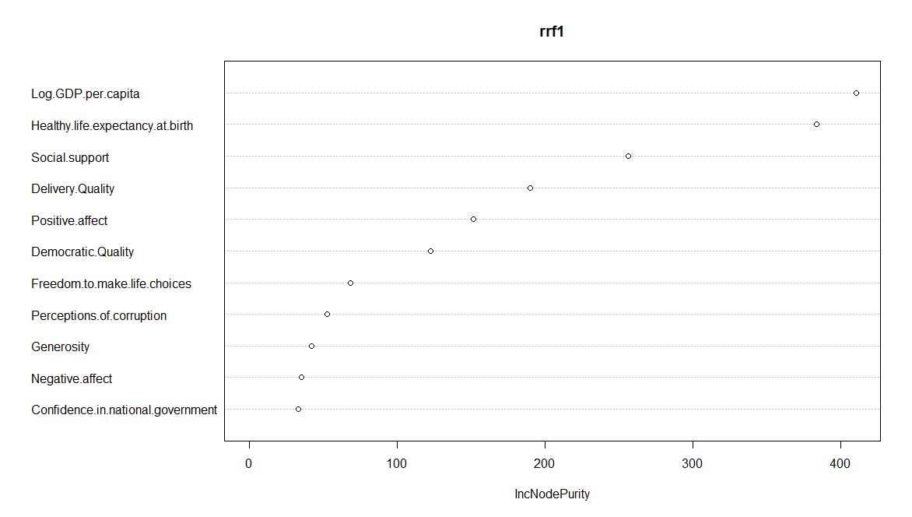

The next step was to measure the predictive accuracy of the model for the validation dataset. The RMSE for the validation dataset is 0.459928 which is slightly more than that of the training set. This indicates that the model is quite good and can be used for further analysis.
In the next step, we created a new dataset which is a subset of the original standardized dataset with Country = “India” and we further applied the above model on this new dataset to predict the life ladder values for India. The RMSE for this new data comes out to 0.3722448 which is impressive suggesting that our model predicts the value really well.
Correlation between predicted values of the validation dataset and the actual values of the validation dataset is 0.9114853. Whereas, correlation between predicted values of the new dataset and the actual values of the new dataset is 0.5445108 which is quite low. One reason for the lower correlation coefficient could be the size of the dataset. Since we are trying to predict the values only for India, the results may not be as desired.

Model 2: Multiple linear regression

- Multiple linear regression with all the 12 predictors

Here we fit the model using the original standardized dataset with all the 12 predictor variables. For this model, the RMSE and R squared values are-

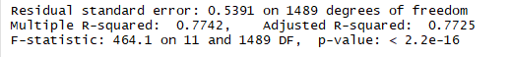

- Multiple linear regression with 6 most important variables

Here we fit the model using the original standardized dataset with 6 most important predictor variables. For this model, the RMSE and R squared values are-

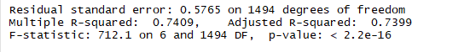
This shows that this model with 6 predictors does not fit as well as the model with all the 12 predictors.
Also, these 2 models demonstrate multicollinearity signifying that the independent variables are highly correlated with each other. This is tested using both Correlation matrix and Variance Inflation Factor (VIF) values.

Model 3: Regression using Neural Nets

Neuralnet package is used to train neural networks for the training dataset which is further used to predict the values for the validation dataset. To train the neural network, various combinations of hidden layers and hidden layer nodes are used to validate the prediction performance. Number of nodes for the input layer is selected as 6 i.e. using the 6 most important predictors in the input layer and 1 node i.e. Life Ladder in the output layer. The various threshold value selected are 0.05, 0.1, 0.5 and the stepmax = 1e+06 to allow maximum steps for the training of the neural network. For each of these neural net models, the RMSE is between 0.53 to 0.59. One of these networks is shown below.

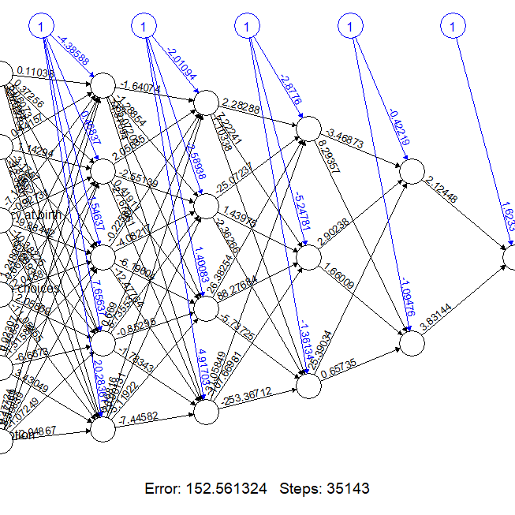

V. Performance Evaluation

All the three models predict well when they are fit using the 6 most important variables- Log GDP per capita, Healthy life expectancy at birth, Social support, Delivery Quality, Positive affect and Democratic Quality. Hence, only these variables are considered for our model selection and prediction.

Of all the above 3 models, R squared value is the largest for model 1 (0.8627024). Also, the RMSE (Root Mean Square Error) for this model is the least- 0.422, indicating that the first model fits the data better than others. Hence, selecting model 1 (Regression using Random Forest) seems to be the best choice for prediction and any other future analysis.

VI. Discussion and Recommendation
Time Series Forecasting

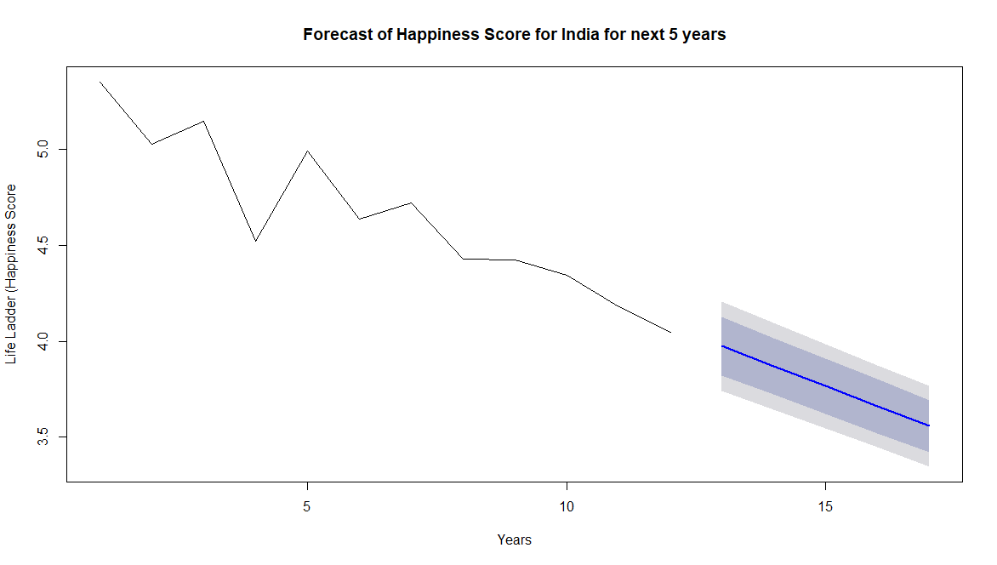

VII. Summary

The case study helped us understand the different techniques used for prediction analysis and their performance in general and for this dataset in particular. The regressive trees or the random forests helped us identify the most important predictor variables for our study. The random forests also demonstrated a better predictive accuracy as compared to other models used in our study. Through this study, we also learnt that multicollinearity in the dataset degrades the predictive accuracy of the multiple linear regression model and hence should be avoided. Thus, the model we built to predict the happiness score works well can be used to predict the happiness scores for any given country, in future.
We came across an interesting finding while studying the subset of this dataset i.e. the data for India. The time series forecast model of the happiness score for India demonstrated that India’s happiness score will further decline in the next 5 years. This is contrary to the fact that the log GDP per capita, healthy life expectancy at birth, Democratic and Delivery quality for the country are increasing- which are few of the major contributors to the happiness score. This brings us at a point that suggests that the current set of predictor variables are not enough to understand the nature of this decline in happiness score for India. There must be some other factors contributing to the overall happiness score of India. And we need to study deeper to identify these parameters and their relationship with the happiness score. If these (unknown) parameters are controlled and promoted along with log GDP, healthy life expectancy, democratic and delivery quality, social support and positive affect; then India’s happiness score will start increasing. Thus, we can restore the Indian happiness by contemplating these contributors and formulating policies accordingly.

Appendix: R Code for use case study

#Reading the data file
setwd("C://Data Mining/Case Study")
WHR.df <- readxl::read_xlsx("Final Data File.xlsx")
#Data visualization
var_year17 <- WHR.df[which(WHR.df$year == 2017),3]
var_year16 <- WHR.df[which(WHR.df$year == 2016),3]
var_year15 <- WHR.df[which(WHR.df$year == 2015),3]
var_year14 <- WHR.df[which(WHR.df$year == 2014),3]
par(mfrow = c(2,2))
hist(var_year$`Life Ladder`, main = "Histogram of World Happiness Score 2017", col = "blue")
hist(var_year16$`Life Ladder`, main = "Histogram of World Happiness Score 2016", col = " light blue")
hist(var_year15$`Life Ladder`, main = "Histogram of World Happiness Score 2015", col = " sky blue")
hist(var_year14$`Life Ladder`, main = "Histogram of World Happiness Score 2014", col = " navy blue")
var_India <- WHR.df[which(WHR.df$country == 'India'),3]
var_India <- WHR.df[which(WHR.df$country == 'India'),c(2:3)]
plot(var_India$year, var_India$`Life Ladder`, type = "o", main = "Happiness Score for India", xlab = "Years", ylab = "Happiness Score")

library(gplots)
WHR.df_heatmap <- WHR.df[,-c(1:2)]
par(mfrow = c(1,1))
heatmap.2(cor(WHR.df_heatmap), Rowv = FALSE, Colv = FALSE, cellnote = round(cor(WHR.df_heatmap),2), notecol = "black", key = FALSE, trace = "none", margins = c(6,6))

#Standardize the dataset
funct_std <- function(x){(x - mean(x))/(sd(x))}
WHR.std.df <- as.data.frame(lapply(WHR.df[,-c(1:3)], funct_std))
var1 <- WHR.df[,1:3]
newdata.df <- c(var1,WHR.std.df)
newdata.df <- as.data.frame(newdata.df)
#Partition the dataset
train.df <- newdata.df[which(newdata.df$year < 2017),]
valid.df <- newdata.df[which(newdata.df$year == 2017),]
train.df <- train.df[,-c(1:2)]
valid.df <- valid.df[,-c(1:2)]

#Random Forest
library(party)
library(caret)
rf <- cforest(Life.Ladder ~ ., data = train.df)
cforestStats(rf)
rev(sort(varImp(rf)))
rf.predict <- predict(rf, newdata = valid.df)
RMSE(rf.predict, valid.df$Life.Ladder)
India.df <- newdata.df[which(newdata.df$country == "India"),]
India.pred <- predict(rf, newdata = India.df)
RMSE(India.pred, India.df$Life.Ladder)
cor(India.pred, India.df$Life.Ladder)
cor(rf.predict, valid.df$Life.Ladder)

#Multiple Linear Regression
library(car)
fit1 <- lm(Life.Ladder ~ Log.GDP.per.capita + Social.support + Healthy.life.expectancy.at.birth + Freedom.to.make.life.choices + Generosity + Perceptions.of.corruption + Positive.affect + Negative.affect + Confidence.in.national.government + Democratic.Quality + Delivery.Quality, data = newdata.df)
summary(fit1)
fit2 <- lm(Life.Ladder ~ Log.GDP.per.capita + Healthy.life.expectancy.at.birth + Social.support + Delivery.Quality + Positive.affect + Democratic.Quality, data = newdata.df)
summary(fit2)

#Neural Net
library(neuralnet)
nn.1 <- neuralnet(Life.Ladder ~ Log.GDP.per.capita + Healthy.life.expectancy.at.birth + Social.support + Delivery.Quality + Positive.affect + Democratic.Quality, data = train.df, hidden = 4, threshold = 0.1, stepmax = 1e+06)
predict1 <- compute(nn.1, data.frame(valid.df$Log.GDP.per.capita, valid.df$Healthy.life.expectancy.at.birth, valid.df$Social.support, valid.df$Delivery.Quality, valid.df$Positive.affect, valid.df$Democratic.Quality))
nn.2 <- neuralnet(Life.Ladder ~ Log.GDP.per.capita + Healthy.life.expectancy.at.birth + Social.support + Delivery.Quality + Positive.affect + Democratic.Quality, data = train.df, hidden = 5, threshold = 0.1, stepmax = 1e+06)
predict2 <- compute(nn.2, data.frame(valid.df$Log.GDP.per.capita, valid.df$Healthy.life.expectancy.at.birth, valid.df$Social.support, valid.df$Delivery.Quality, valid.df$Positive.affect, valid.df$Democratic.Quality))
nn.3 <- neuralnet(Life.Ladder ~ Log.GDP.per.capita + Healthy.life.expectancy.at.birth + Social.support + Delivery.Quality + Positive.affect + Democratic.Quality, data = train.df, hidden = c(4,3), threshold = 0.1, stepmax = 1e+06)
predict3 <- compute(nn.3, data.frame(valid.df$Log.GDP.per.capita, valid.df$Healthy.life.expectancy.at.birth, valid.df$Social.support, valid.df$Delivery.Quality, valid.df$Positive.affect, valid.df$Democratic.Quality))
nn.4 <- neuralnet(Life.Ladder ~ Log.GDP.per.capita + Healthy.life.expectancy.at.birth + Social.support + Delivery.Quality + Positive.affect + Democratic.Quality, data = train.df, hidden = c(4,3,2), threshold = 0.1, stepmax = 1e+06)
predict4 <- compute(nn.4, data.frame(valid.df$Log.GDP.per.capita, valid.df$Healthy.life.expectancy.at.birth, valid.df$Social.support, valid.df$Delivery.Quality, valid.df$Positive.affect, valid.df$Democratic.Quality))
RMSE(predict1$net.result, valid.df$Life.Ladder)
RMSE(predict2$net.result, valid.df$Life.Ladder)
RMSE(predict3$net.result, valid.df$Life.Ladder)
RMSE(predict4$net.result, valid.df$Life.Ladder)

#Time Series Forecasting

library(forecast)

auto.arima(India.df$Life.Ladder)
Box.test(India.df$Life.Ladder, type = "Ljung-Box")
ind.forecast <- forecast(India.df$Life.Ladder, h= 5)
plot(ind.forecast, xlab = "Years", ylab = "Life Ladder (Happiness Score", main = "Forecast of Happiness Score for India for next 5 years")

